The Islamia University of Bahawalpur
Department of Information Technology


Project Proposal
(SCOPE DOCUMENT)
for

<Travia>

Version 1.0

By
Muhammad Husnain Arshad
F24BINFT7M04027
Session Fall 2024 – 2026
Muhammad Danish Sattar
F24BINFT7M04008
Session Fall 2024 – 2026

Supervisor
Dr. Muhammad Asad Ullah

Table of Contents
Abstract 1
Introduction 1
Problem Statement 1
Problem Solution for Proposed System 1
Related System Analysis/Literature Review 1
Advantages/Benefits of Proposed System 2
Scope 2
Modules 2
Software Process Methodology 3
Mockups 4
Conclusion 5
References 5
Plagiarism Report 5

Project Category: (Select all the major domains of proposed project)

A-Desktop Application/Information System
C- Problem Solving and Artificial Intelligence
B-Web Application/Web Application based Information System
D-Simulation and Modeling
E- Smartphone Application
F-
Smartphone Game G- Networks H- Image Processing Other (specify category) Mobile Application

Abstract
The "Travia" is a feature-rich mobile application created with Flutter with the goal of improving and streamlining users' travel planning experiences. Through the integration of many features including itinerary planning, hotel booking, flight and transportation management, and recommendations for local activities, the app seeks to offer passengers an all-in-one solution. The Travia makes sure customers can plan their vacations from beginning to end with ease thanks to its intuitive UI and smooth navigation.

The application provides individualized travel recommendations based on user interests, historical travel patterns, and popular places by utilizing real-time data and sophisticated algorithms. The ability to work with friends and family on travel plans is made possible by key features including social sharing choices, weather updates, interactive maps, and budget tracking. The Travel preparation App seeks to improve the overall travel experience by reducing the stress and complexity commonly associated with trip preparation by consolidating all aspects of travel planning into a single platform.

Introduction
This project proposal paper outlines the creation of a mobile application called the "Travia" which is based on Flutter and aims to improve and streamline the travel planning process. This paper will give a thorough overview of the reasons behind the system's requirement, its main features, and the advantages it hopes to bring to its users.
Planning a trip can often be a laborious and time-consuming process that involves using a variety of platforms to reserve lodging, activities, and flights. It is often difficult for travelers to plan their trips, control their spending, and get trustworthy local information. By providing a centralized, user-friendly solution that combines all necessary travel planning resources into a single application, the Travia aims to alleviate these pain points.

Through the use of Flutter's cross-platform features, the application will provide a reliable and excellent user experience on Android smartphones. The system will offer real-time weather and travel advisory updates, real-time itinerary management, transportation alternatives, and bookings for lodging and flights. It will also include sophisticated algorithms to offer tailored trip recommendations and budget monitoring tools to assist users in properly managing their spending.
With this project, we hope to develop a user-friendly, feature-rich Trivialization that streamlines the procedure and improves the trip experience in general. Travel planning will be accessible and fun for everyone with the help of the Travia, which will appeal to a wide spectrum of travelers, from families and groups to lone travelers.

Problem Statement
What problem does your software solve?
The difficulties and inefficiencies involved in planning travels are addressed by the Travia. These days, arranging a trip frequently necessitates using several platforms to arrange lodging, activities, and flights, which may be laborious and time-consuming. Travelers also have trouble keeping track of their spending, organizing their itinerary, and finding trustworthy local information. This software offers a comprehensive solution that simplifies and improves the ease, effectiveness, and enjoyment of travel planning.

Why you are developing this system?
Our system is being developed to provide passengers with an all-inclusive tool that streamlines travel planning in every way. With features like real-time weather updates, schedule management, travel alternatives, and hotel and flight bookings integrated, the app seeks to lessen the hassle and complexity that come with arranging a trip. A wide spectrum of customers will find the vacation experience more fun and accessible with the addition of high-quality videos and reviews, offline access, packing, and expenditure management.

Does the same system already exist? If yes, how will a re-implementation aid your learning?
Actually, there are Travias out there, but a lot of them are feature-poor and don't offer a smooth user experience. With the re-implementation and improvement of these functionalities in a single app, this project will provide a more coherent and intuitive solution. Through the exploration and utilization of cutting-edge technology and development techniques, this re-implementation will support our learning. In particular, we will obtain practical experience with the cross-platform features of Flutter, the integration of different booking systems, and the creation of advanced algorithms for tailored suggestions and financial management.

What skills do you expect to learn from this project?
Through this initiative, we hope to gain a variety of useful talents, such as:

- Proficiency with Flutter in order to construct cross-platform mobile applications.
- Incorporating real-time data sources for travel advisories and weather updates.
- Application of complex algorithms to provide customized travel suggestions.
- Creation of data management and offline access features.
- Database Management Gaining proficiency in integrating and managing databases, such as Firebase or SQLite, for storing and retrieving medical records and other data.
- Implementing secure authentication methods and ensuring data privacy and security, adhering to industry standards and regulations like HIPAA.
- Methods for keeping trip schedules, budgets, and packing lists under control.
- Integration with multiple travel, lodging, and excursion booking providers.
- Use of UI/UX design concepts to provide a seamless user experience.
- Integrating high-quality videos and reviews to improve the way users make decisions.

Problem Solution for Proposed System
• Integrated Platform: Removes the need to flip between several platforms by combining all
Necessary trip planning tools into a single app.
• Real-time weather updates and travel advisories: Help users make informed decisions by
Giving them the most recent information on the weather and any potential disruptions.
• Real-time itinerary management: It is possible for users to effectively arrange and modify
Their itineraries while on the go with real-time itinerary management.
• Alternatives for Transportation and Booking Integration: Provides easy ways to book
accommodations, flights, and other forms of transportation through the app by gaining
access to a number of booking providers.
• Advanced Algorithms for Personalized Recommendations: Offers customized travel
recommendations based on user interests, historical travel patterns, and popular locations.
• Budget monitoring tools: By keeping track of expenditure and establishing spending caps,
They assist users in properly managing their expenses.
• Offline view: This feature, which is helpful in isolated locations or areas with poor
connectivity, allows users to view their maps, itineraries, and other important information
without an internet connection.
• Packing and Expense Management: To guarantee a seamless trip experience, consumers
Can receive assistance in organizing packing lists and monitoring expenses.
• High-quality videos and reviews: Provide trustworthy information from other travelers on
Places to go, things to do, and lodging, which helps with decision-making.
• Improved User Experience: The application guarantees a reliable and excellent user
experience on Android smartphones by utilizing Flutter's cross-platform capabilities.
All-Inclusive Travel Planning Solution: The app helps a variety of travelers plan their trips more effectively, joyfully, and easily by tackling a number of different issues.

Related System Analysis/Literature Review

Table 1 Related System Analysis with proposed project solution
Application Name | Weakness | Proposed Project Solution
Wanderlog | Limited offline access, basic budgeting tools, lacks integration with various booking services. | Provides comprehensive offline access, robust budgeting tools, and seamless integration with multiple booking services.
TripAdvisor | Focused mainly on reviews, limited itinerary management, no packing or expense management features limited offline access. | Includes detailed itinerary management, packing and expense management features, improved offline access, and maintains quality reviews and recommendations.
Triplet | Limited personalized recommendations, basic trip planning functionality, lacks real-time updates for weather and advisories. | Utilizes sophisticated algorithms for personalized trip recommendations, offers comprehensive trip planning tools, and provides real-time weather updates and travel advisories.

Advantages/Benefits of Proposed System

Entire Offline Access: Travelers in rural areas or places with poor connectivity might benefit greatly from the ability to access itineraries, maps, and vital information without the need for an internet connection.

Combined Reservation Services: The app offers a smooth and efficient booking experience by integrating several booking services for travel, lodging, and activities. Through the app, users can book bookings and compare pricing.

Particularized Suggestions: Tailored trip ideas are provided by sophisticated algorithms that take into account user preferences, historical travel patterns, and popular places. This guarantees a more pleasurable and customized travel experience.

Detailed Planning and Scheduling: With real-time information, users can effectively plan, manage, and organize their travel schedules. This tool improves overall travel organization with day-by-day planning, reminders, and simple alterations.

Effective Expense Management and Budgeting: The app helps users successfully manage their travel expenses by providing options for budgeting, tracking spending, and establishing limitations. This function guarantees that passengers can avoid unforeseen expenses and stay within their budget.

Excellent Videos and Evaluations: uses high-quality videos and user reviews to deliver trustworthy information about travel locations, lodging options, and activities. This improves travelers' experiences and aids in decision-making.

Improved User Experience: Utilizing Flutter's cross-platform features guarantees a superior, consistent user experience across iOS and Android devices. All customers find that vacation planning is more accessible and fun because to the user-friendly interface and intuitive design.

Scope
The Travia's functionality spans a broad range of features designed to improve and expedite users' travel planning experiences. The proposed project's primary features are itinerary management, bookings for lodging and airfare, several modes of transportation, budget tracking, and customized travel suggestions. With options for reminders and real-time updates, users will be able to conveniently create, change, and manage their trip schedules. Users will be able to compare costs and make reservations within the app thanks to its smooth connection with a variety of booking services for travel, lodging, and local activities. Sophisticated algorithms will offer customized travel suggestions according to user choices and previous journey experiences, guaranteeing a unique and remarkable journey. Throughout their journey, customers will be able to properly manage their spending and keep track of their expenses with the help of budgeting tools. To further improve the user experience, the app will also provide offline access, packing lists, expense management, and high-quality reviews and videos. But it doesn't include things like real booking transactions (handling payments), language translation services, or a ton of social networking capabilities. The Travia's overall goal is to provide passengers with a thorough and intuitive solution that makes travel planning easy, effective, and pleasurable.

Modules
Module 1: Module for Itinerary Management
This module enables users to effectively establish, modify, and oversee their trip schedules. Users can organize their plans using an intuitive interface by entering details like locations, dates, activities, and comments. The module makes sure customers always have access to the most recent information by including tools for real-time updates, reminders, and device syncing. Users can also alter their plans in accordance with their own priorities, travel objectives, and personal tastes.

Module 2: Booking Integration Module
This module offers users a smooth and practical booking experience by integrating many booking services for travel, lodging, airlines, and activities. Within the app, users can read reviews, compare costs, look for possibilities, and book reservations. The module makes sure users have all their travel information in one location by including capabilities for safe payment processing, tracking confirmations, and itinerary synchronization. One of the unique features that helps users find the ideal options for their vacation is the ability to limit search results based on preferences like price range, type of accommodation, and activity category.

System Limitations/Constraints
- Internet connectivity is still necessary for users to access real-time updates, booking services, and some sophisticated functionality, even if the app allows offline access for some elements, like itinerary management and some informative content. This restriction can present difficulties for users visiting isolated locations with spotty or nonexistent internet connectivity.

- Dependency on Third-Party Services: Third-party APIs and services are necessary for the integration of different booking systems. The performance and dependability of the application may be impacted by any modifications or disruptions to these external services. Furthermore, there may be differences in the quantity and caliber of data offered by various services, which could have an impact on the accuracy and comprehensiveness of the information consumers receive.

- Device Compatibility: Although the app strives to offer a flawless user experience on iOS and Android devices, there can be functional differences or restrictions between various device types, OS versions, and screen sizes. It might take more development work and testing resources to ensure compatibility and optimization for a variety of devices.

Software Process Methodology
The Agile software development process has been selected for the creation of the Travia. Agile places a strong emphasis on customer feedback throughout the development process, cross-functional team cooperation, and iterative development. Agile was our choice due of its adaptability and flexibility, which let us successfully adjust to shifting priorities and requirements. Agile also promotes customer interaction and ongoing improvement, guaranteeing that the finished product satisfies our users' changing needs and expectations. This process allows us to provide a high-quality product within the given timeframe and fits in well with the experience of our development team.

Tools and Technologies
Mention all the hardware/software tools and technologies with version number which will be used in implementation of the project.
Tools And  Technologies | Tools | Rationale
Tools And  Technologies | Flutter | The UI toolkit for building natively  Compiled applications for mobile.
Tools And  Technologies | Figma | Tools for creating UI designs
Tools And  Technologies | Android Studio or VS Code | IDEs for Flutter development or providing coding and debugging.
Tools And  Technologies | MS Word | Documentation
Tools And  Technologies | MS Power Point | Presentation
Tools And  Technologies | Technology | Rationale
Tools And  Technologies | Dart | Primary Programming language for Flutter Development
Tools And  Technologies | Firebase | Provides backend services.
Tools And  Technologies | Dart | Primary Programming language for Flutter Development

Mockups

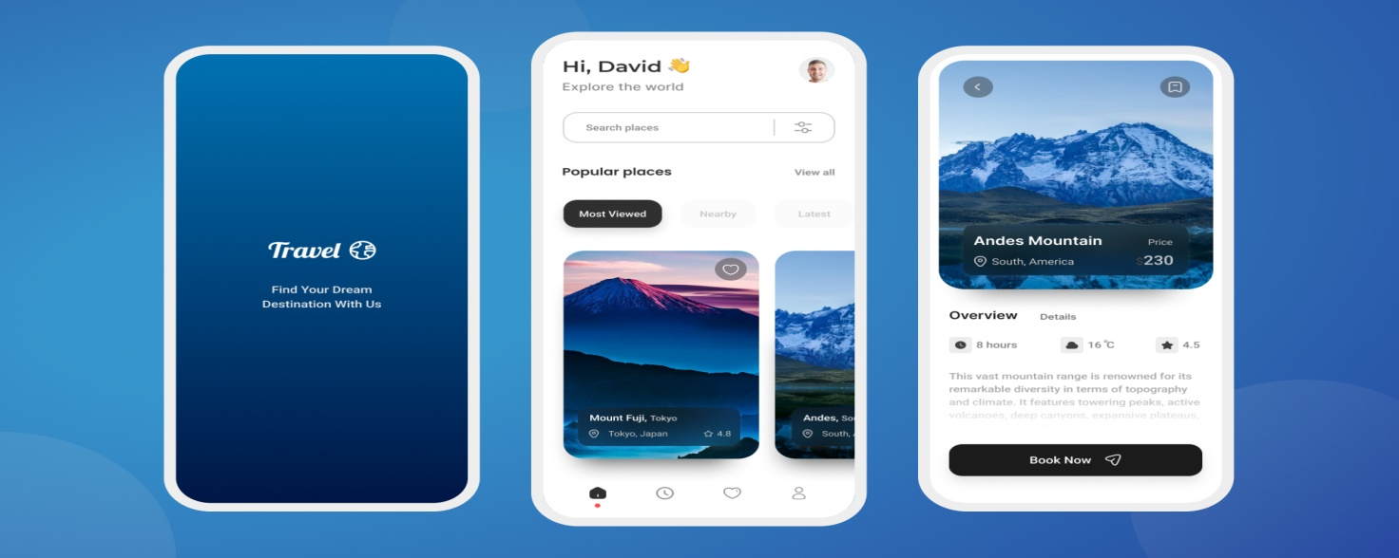

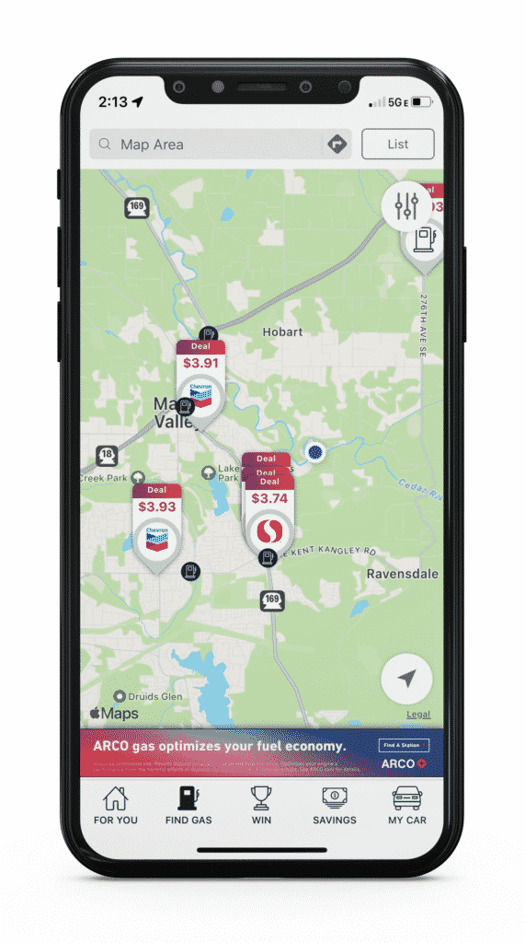

Conclusion
In conclusion, by offering travelers a comprehensive and user-friendly solution, the suggested vacation Planning App seeks to completely transform the vacation planning process. The software aims to simplify and improve every facet of trip planning by solving the shortcomings of current applications and adding cutting-edge features like itinerary management, booking integration, personalized recommendations, and budget tracking. We are sure we can provide a better solution that fulfills the needs and expectations of our users since the Agile software development methodology is driving our process. We are excited to set off on this adventure and produce a useful application that enables everyone to organize trips in an easy, effective, and pleasurable manner.

References
(https://www.javatpoint.com/flutter)
(https://www.coursera.org/search?query=flutter)
(https://www.tutorialspoint.com/flutter/index.htm)

